How dirty is your retirement?

(Where there is Dutch text in screenshots, the translation can be found directly below.)

Eating less meat, taking shorter showers, not flying anymore. Do you already have solar panels? Anyone who wants to reduce his/her carbon footprint can sometimes become despondent. Moreover: while you may be doing your best, large financial institutions, including pension funds, are still investing billions in the fossil industry. They can really make a difference. Wondering what your pension fund is doing with your money?

If we review the investments of ten major pension funds, we arrive at a total invested capital in the fossil industry of 20 billion euros. Of this, over 7 billion euros is in companies that largely extract, trade, transport or use brown and/or coal to generate electricity. This quickly amounts to thousands of euros per participant:

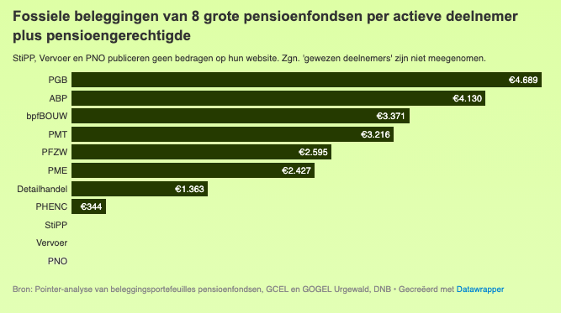
(HEADER: Fossil investments of 8 large pension funds per active member plus pensioner)

Below you will find a detailed overview of the fossil investments of the ten largest pension funds and a reaction of the funds to our findings.

Theater maker Thomas Lamers actively opposes his pension fund PFZW's fossil investments. He and his theater collective Walden do everything they can to keep their carbon footprint as small as possible. They no longer use diesel generators at venues. They encourage audiences to come by public transportation or bicycle. Can they bring their own water bottle?

"I find it really quite embarrassing that I go to so much trouble and squeeze myself into corners like this with my modest theater group, while a pension fund doesn't impose those same ethical standards on itself."

We cannot switch completely to renewable energy overnight, Lamers also understands that. Therefore, fossil fuel companies' operations will be needed for some time to come. But do we also need to tap new oil and gas fields? And what about the most polluting fossil fuels, such as tar sands, and coal? Pension funds appear to be investing in these activities as well.

TILES:
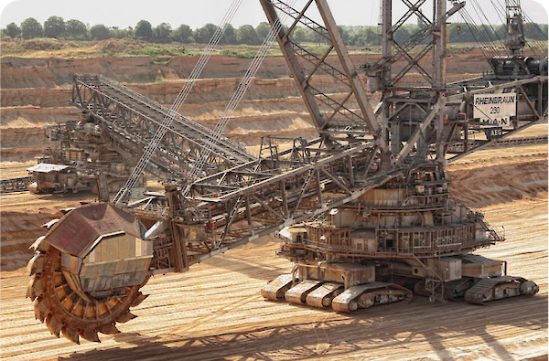
German lignite industry
This monster is a Bucket-wheel excavator from the German coal company RWE. The largest land vehicle in the world. Like a giant scraper, some 80 meters long, it mines 265 million kilograms of lignite per day! Lignite is the most polluting fossil fuel. 8 out of 10 pension funds together invest more than 150 million euros in RWE.

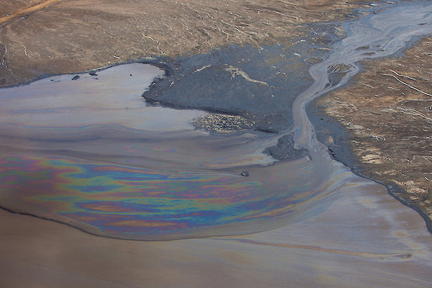
'Most destructive project on earth'
TotalEnergies is an oil and gas giant. Besides extracting a lot of oil and gas, they search and develop new oil and gas fields and lay new pipelines. In Africa, they are the largest in this. We also meet them with an interest in what is also called the "most destructive project on earth": the Athabasca tar sands in Canada. We come across total investments of 850 million euros in TotalEnergies in nine pension funds.

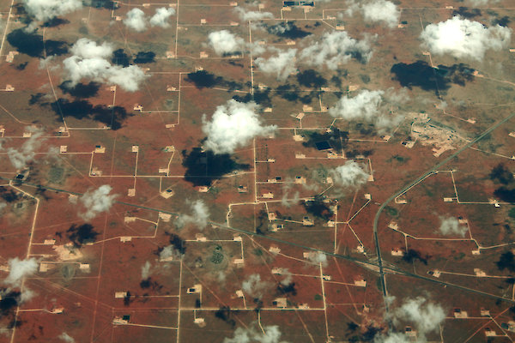
Highest greenhouse gas emissions
Altogether, our surveyed pension funds invest some 2.7 billion euros in companies operating in the part of the planet where the most greenhouse gases shoot into the atmosphere: the Permian Basin in the U.S. states of New Mexico and Texas. Here, oil and shale gas are extracted in an extremely intensive and polluting way. Among others, by ExxonMobil, Chevron and BP.

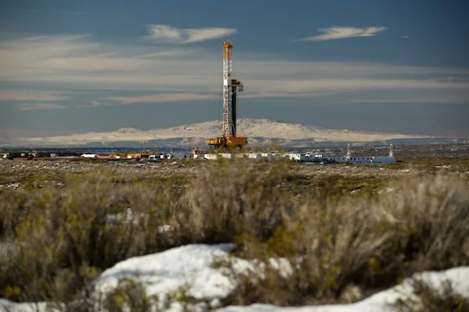
1,700 drilling sites in area the size of Belgium
In the Northern Patagonia region of Argentina, some 23 companies are drilling for oil and gas at more than 1,700 drilling sites. Here is the giant Vaca Muerta fracking project in an area the size of Belgium. Argentina's Ministry of Energy reports that a total of 276 new wells were drilled last year. In all, they accounted for 40 percent of Argentina's annual oil production and half of its annual gas production. 8 pension funds invest a combined total of some 3.5 billion euros in companies drilling in the area.

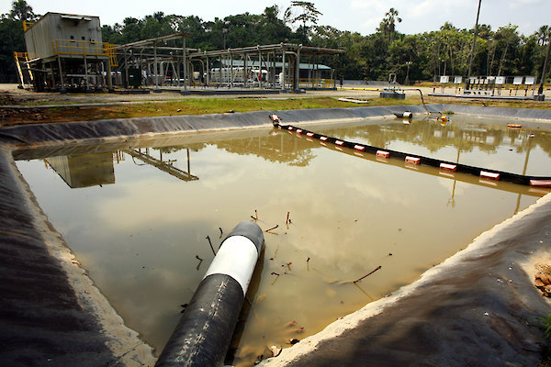
Oil and gas from the Amazon
In January 2022, more than a million liters of heavy oil spewed from a pipeline operated by the company OCP. The oil contaminated a section of rainforest in Ecuador. A similar oil spill happened in the same region back in 2020. Many indigenous peoples here live off and in the jungle. Some 22 oil and gas companies are deforesting the jungle in search of oil and gas. 8 of the Dutch pension funds we researched together invested about 265 million euros in companies active in the extraction or distribution of oil and gas in this area.

Thomas, of course, is not alone in worrying about the agonizingly slow transition to clean energy and the dangers it poses. According to United Nations Secretary-General Antonio Guterres, we are fighting "the battle of our lives." He seizes on every speech to ratchet up the pressure, including again at the last climate summit.

There he stressed the importance of sustainable investments by financial institutions. Instead, according to him, they make "false promises of climate neutrality" with which they "conceal massive expansion of fossil energy." "Reprehensible," he concluded.
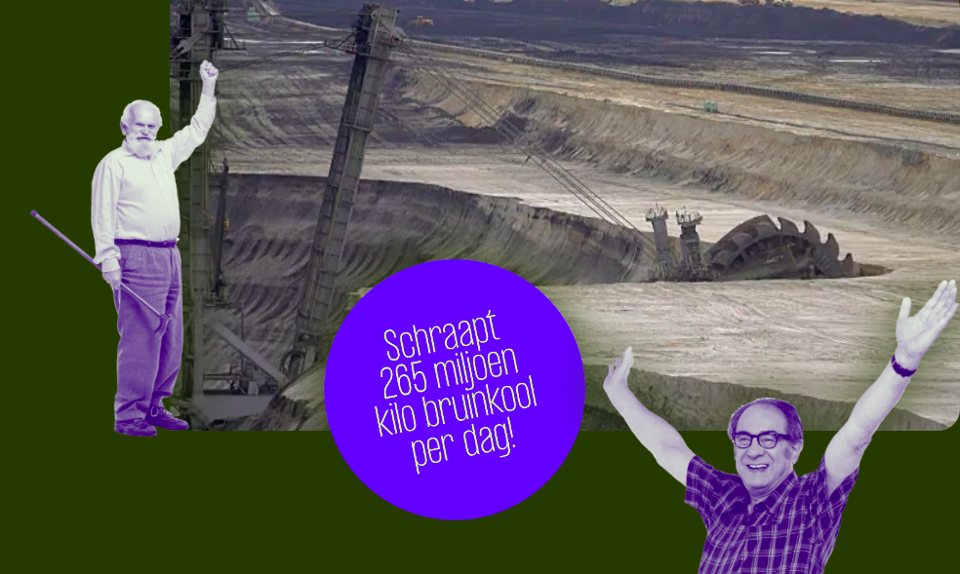
(TEXT IN IMAGE: Scrapes 265 million pounds of lignite per day!)

"We are on a highway to climate hell, with our foot still on the gas pedal"
- UN Secretary-General Guterres

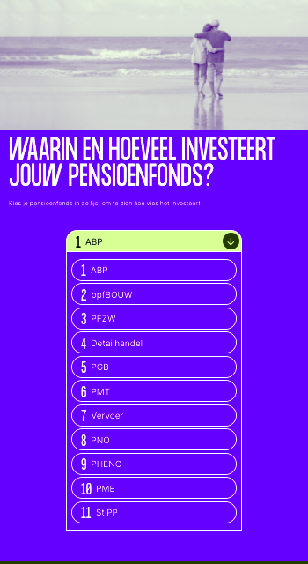
TRANSLATION: WHAT AND HOW MUCH DOES YOUR PENSION FUND INVEST IN?
Choose your pension fund in the list to see how dirty it invests
EXAMPLE OF THE FIGURES FOR ABP:

Invests in the
fossil industry for
€ 4130
per participant

Investment portfolio
from 30-06-2022

Coal: Number of companies: 58
Total amount: €4.0 bln

Oil or gas extraction: Number of companies: 83
Total amount: €4.1 bln

Oil or gas transport: Number of companies: 58
Total amount: €3.5 bln

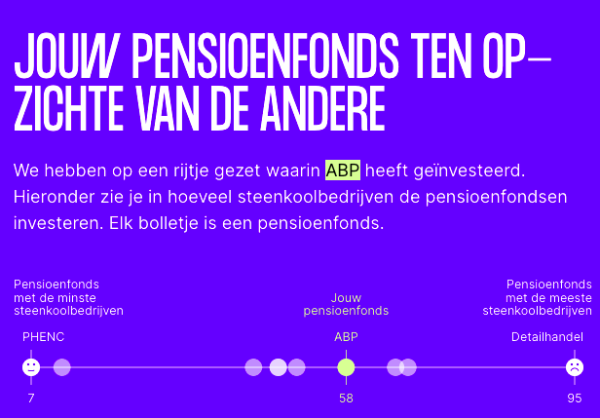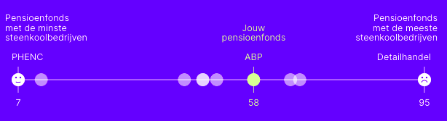
TRANSLATION:
YOUR PENSION FUND COMPARED TO THE OTHERS
We've listed what ABP has invested in. Below you can see how many coal companies the pension funds invest in. Each bullet is a pension fund.

Chart left: Pension fund with the fewest coal companies
Chart middle: Your pension fund
Chart right: Pension fund with the most coal companies

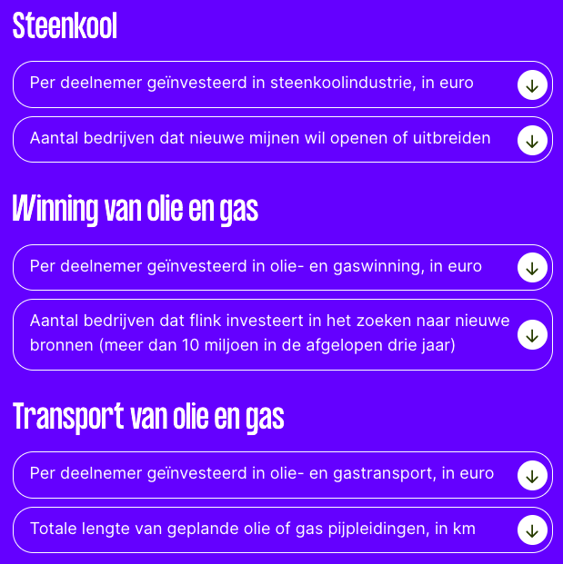
TRANSLATION:
Coal
Per participant invested in coal industry, in euros
Number of companies planning to open or expand new mines

Extraction of oil and gas
Per participant invested in oil and gas extraction, in euro
Number of companies investing heavily in searching for new sources (more than 10 million euros in the last three years)

Transport of oil and gas
Per participant invested in oil and gas transportation, in euros
Total length of planned oil or gas pipelines, in km

Pointer sent all the pension funds featured in this special a list of their fossil investments and asked them to respond. In addition, the editors checked their sustainability policies. Pension funds use roughly two different strategies to make their investment portfolios more sustainable: exclusion (stopping investing in certain companies) and engagement (engaging in dialogue to try to steer the company in a more sustainable direction). They all say they support the goals of the Paris Climate Agreement. The most important: maximum 2 degrees temperature increase in 2050, preferably no more than 1.5 degrees.

(Only the response of the chosen pension fund is shown. See below the responses of the other pension funds.)

ABP's response
ABP decided in October 2021 to stop investing in producers of oil, gas and coal (companies that derive more than 1 percent of their revenue from coal mining, oil or gas extraction). In addition, ABP no longer invests in companies in the fossil chain that derive more than 20 percent of their turnover from other fossil activities. An exception will only be made if it is determined that the company can play a role in the energy transition. ABP says it thereby wants to make a contribution to limiting global warming. "By April 2023, the majority of these investments will have been sold," ABP said. In addition, the fund uses engagement to reduce companies' carbon emissions. Soon, ABP will publish a new climate policy with the measures it is taking to better contribute to the 1.5-degree Paris target, the fund writes in a response.

Thomas Lamers prefers to arrange his money matters with institutions where sustainability is paramount. "I switched to an ethical bank, I also took out a slightly more expensive mortgage there. But I'm tied to a certain pension fund because of my collective bargaining agreement, so I can't vote with my feet there. I can't say as a consumer: now I take my money and go somewhere else."

Would you like your pension fund to invest your money more sustainably? Pointer is told by several pension funds that they listen to participants. Pension funds have accountability bodies, do participant surveys through panel discussions or surveys. They also often have a complaint center.

Sources: corporate investment pension funds (websites or sent) | Global Coal Exit List 2022 and Global Oil & Gas Exit List 2022 (Urgewald) | number of active members (without 'former members') + pensioners (Annual Data on Individual Pension Funds, DNB)

How we scrutinize pension funds' fossil investments

Pension investments in fossil industry (dataset)

Broadcast: green pension?

END

Responses of other pension funds:

Response from bpfBOUW
BpfBouw says to have sold by 2021 investments in companies with a turnover of which more than 30 percent was derived from coal mines or more than 20 percent from tar sands. In addition, the largest oil and gas companies and electricity producers must have a long-term target for reducing their CO2 emissions, in line with the Paris Climate Agreement. In addition, BpfBouw enters into a dialogue with companies about sustainability. By doing so, the fund hopes to get fossil companies on a more environmentally friendly path. According to BpfBouw, it also invests in fossil companies "that can potentially make a positive contribution to the energy transition." Therefore, the fund does not exclude those companies (for now).

Reaction of PFZW
PFZW says it no longer wants to invest in companies that derive more than 5 percent of their turnover from coal mining or more than 1 percent from the (highly polluting) extraction of oil from tar sands. Companies that do not comply with the Paris Climate Agreement by 2024 will be sold. According to PFZW, a minority of the fund's fossil investments currently comply. PFZW: "This is the reason PFZW deploys a mix of policy instruments as part of its climate policy." Initially, the fund uses an engagement strategy.

Response from Retail
Pensioenfonds Detailhandel does not exclude fossil companies because the fund believes it would lose influence. That's why it is turning to engagement. "We urge companies in which we invest to do business responsibly. We do this on the basis of international treaties, guidelines and covenants," the fund says on its website. If the time-bound targets attached to an engagement process are not achieved, exclusion may be the next step.

Due to time constraints, Pensioenfonds Detailhandel decided not to respond to the data.

Response from PGB
PGB is the fund that invests the most fossil euros per active participant and recipient (220,000 in total) (4,689 euros). It is also the only fund in our survey that does not want us to publish the fund's list of fossil investments without their permission. We can therefore only publish the totals of their investments by industry. PGB also does not publish this data itself but has shared it with us, at our request.

In its sustainability policy, PGB states that it aims to halve CO2 emissions in its investment portfolio by 2030. PGB wants to achieve this by not investing in companies that owe at least half of their turnover to the coal industry. In addition, the fund applies engagement. PGB: "We do not exclude fossil energy sectors in advance, but we do expect them to be able and willing to demonstrably make the transition to a sustainable economy." About the companies featured in the special, PGB says: "It is possible that a number of companies are on the 'watch list'. These are companies that score poorly on sustainability characteristics but have not yet exceeded the threshold for exclusion." According to the fund, Pointer's data could also include companies that are invested in indirectly. PGB then has no direct control over the investments, because they are made by funds in which PGB invests.

Response from PMT
PMT does not invest in coal producers. It also excludes companies that derive more than 10 percent of their revenue from unconventional oil and gas extraction (through advanced but polluting production methods). In addition, PMT engages with oil and gas and energy-intensive companies.

According to PMT, it is currently not easy to put together a portfolio of companies that comply with the Paris Agreement. PMT: "Currently, none of the oil and gas companies meet the requirements of net zero CO2 emissions by 2050, inside and outside our portfolio. Over the next seven years, we want to invest more and more in companies that are on a 1.5-degree path, and less in companies that are not taking sufficient action."

Response from Transportation
Pensioenfonds Vervoer supports the Paris Agreement commitments and tightened its grounds for exclusion late last year. For example, it no longer invests in companies that derive 5 percent of their revenue from coal, tar sands, Arctic extraction or shale gas and oil. Through engagement, Transport is trying to convince other companies in their investment portfolios to "make energy transition part of their policy." "We expect a neutral to positive long-term impact of our policy choices," the fund said.

Response from PNO
PNO does not exclude investments in fossil fuels. The fund argues that fossil energy will remain necessary in the coming years, which is why it chooses to engage. In this way, the fund tries to encourage energy transition. PNO does expect the companies in which it invests to comply with the Paris Agreement. PNO conducted a participant survey this year: "The results of this survey will most likely lead to a tightening of the socially responsible investment policy," the pension fund writes in its response.

Response from PHENC
PHENC announced its intention to exit fossil in 2021. The fund says it will no longer invest in companies active in coal and tar sands extraction. Companies that derive more than 50 percent of their revenue from oil and gas production will also be excluded. "Combating climate change is an important theme within our responsible investment policy and we have become increasingly aware that investing in fossil energy does not fit within our policy," the fund said. Through engagement, companies still invested in are encouraged to operate more sustainably.

PHenC invests very little in fossil companies. The fund considers the number of companies (19) relatively limited. PHenC also reports that it recently excluded four oil and gas companies. They are (Enbridge, Keyera, Reliance and Tourmaline). "For the other companies, they do not meet the fund's exclusion criteria."

Response from PME
PME announced in 2021 it was the first major pension fund to exit fossil. The pension fund says it will no longer invest in companies involved in the production or distribution of fossil energy (oil, gas, coal, tar sands). In addition, PME is engaging with large consumers of fossil energy to push for a switch to renewable energy. However, Pointer's research found that PME invests in a number of companies that the fund's own policy would require it to exclude. Following our research, PME is still excluding 29 companies that do not meet the climate requirements it sets for itself. PME does continue to invest in companies active in the transport of oil and gas. "These companies are allowed to stay for the time being because we believe they play a role in the energy transition," PME said. Energy companies are also being held - under certain conditions.

Read more about the steps PME has taken as a result of our investigation here.

Response from StiPP
Pension fund StiPP is one of the few pension funds that does not publish their investment portfolios on the website. At our request, StiPP did send us the investment dates but unfortunately too late to be included in this production. In a response, the pension fund says it intends to publish the investment portfolio online from 2023. So that participants will also have access to this information.

StiPP aims for a CO2-neutral investment portfolio in 2050. It is trying to achieve this by engaging with companies. The pension fund considers this a more important means than excluding companies. "First of all, the Paris Agreement concerns a long-term transition, up to 2050. Secondly, StiPP believes in the power of engagement to achieve climate objectives and even considers it an obligation for institutional investors," the pension fund says. Coal producers are excluded, however.

