PME pension fund sells 286 million in fossil investments after Pointer investigation

One of the Netherlands' largest pension funds PME (metal and technology industry) is putting 286 million in fossil investments from 29 companies on sale following our investigation. This includes 230 million in coal investments and 56 million in investments in gas and oil extraction. PME promised to be "coal-free" back in 2018 and said it would sell all fossil investments by 2021. But after our analyses, we found that fossil fuel companies were still in the portfolios. "I found it really frustrating, but also very good that you guys came across that. We take our climate ambition very seriously," said board member Marcel Andringa

Pointer put fossil stocks and bonds from 10 major pension funds next to a list of coal companies, the Global Coal Exit List from the NGO Urgewald. This list includes companies that are largely in the brown and coal industry, meant to generate energy. Pointer's analysis shows that PGB, the social sector pension fund, with 4,689 euros per active pension participant and recipient, is the fund with the most fossil investments. ABP (4130 euros per participant and recipient) and bpfBOUW (3,371 euros per participant and recipient) are in second and third place.

Chart
Fossil investments of 8 major pension funds per active member plus pensioner
StiPP, Transport and PNO do not publish amounts on their websites. So-called "former participants" are not included.

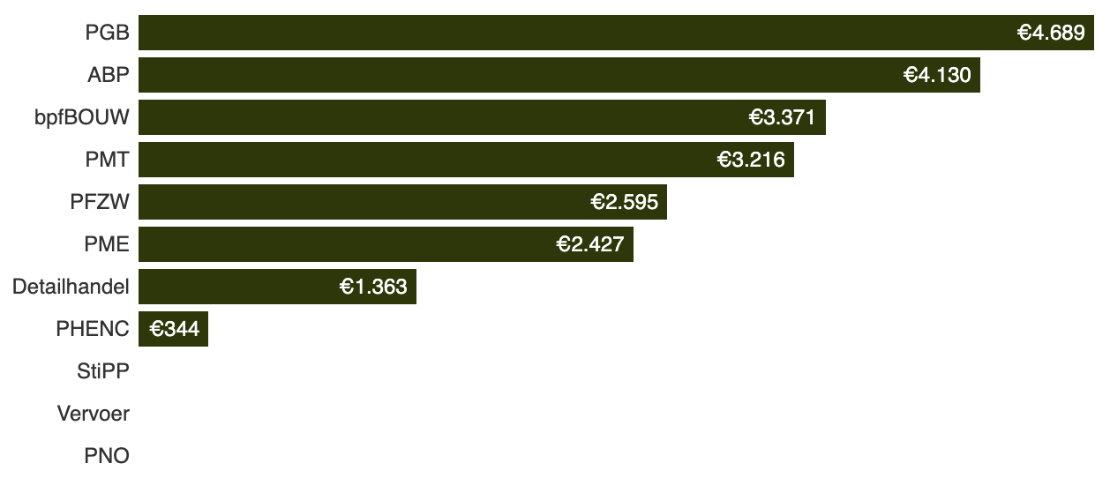
Source: Pointer-analyses van beleggingsportefeuilles pensioenfondsen, GCEL en GOGEL Urgewald, DNB

PME ranks sixth with 2,427 euros per participant, even though it was one of the first pension funds to announce in 2018 that it would be "coal-free." Among other things, it invests in Glencore, the world's third-largest coal producer. In addition to PME, ABP and PHENC also made pledges to sell their fossil shares. ABP expects to have sold most of it by the first quarter of 2023, but still invests in fossil industries at 4,130 euros per active pension member and recipient. The rest of the large pension funds see more benefit in their role as critical shareholders of fossil companies. This "engagement" strategy has never really been successful, according to Bert Scholtens, professor of finance at the University of Groningen.

Not coal-free
PME reacts with surprise to the findings, but could have known. After all, PME relies on databases such as those of financial services provider Bloomberg. In those, a company only counts as a coal producer if it derives more than 50 percent of its sales from coal. Because of this so-called sector classification, huge mining companies like Glencore, which derives 9 percent of its sales from coal, may slip in, and not be excluded. PME's internal policy states that only coal companies that produce coal for most of their operations or derive more than 30 percent of electricity from coal are excluded. But that is not what the fund promised at the time in Daily Mail and on their exclusion page.

Still investing in oil and gas
Coal aside, PME was one of the first pension funds last year to let it be known that further efforts were being made on the energy transition. "PME has sold all investments in fossil oil and gas extraction and distribution in recent months." Even this turns out to be untrue after further inspection of the "Global Oil & Gas Exit List" by Pointer. The fund still invests some 420 million euros in 21 companies active in fossil oil and gas extraction and distribution. Of those, PME will exclude all remaining oil and gas extraction producers as soon as possible. That leaves 6 companies worth 56 million euros. "Companies engaged only in distribution may still be useful for the transition to hydrogen," the fund informs.

PME invests in a lot of companies and therefore cannot know exactly what companies are doing. That's why it relies on financial databases like those of Bloomberg explains Marcel Andringa. But those thus have the limitation that large coal, oil and gas companies do not count as such if they get less than 50 percent of their revenue from that commodity. Andringa now concludes that based on the sector classification, PME cannot say it has completely exited fossil. "So we have now decided to use not only that standard sector classification, but also other public information, which Pointer has also used such as Urgewald. Whatever else you can find to get that picture complete."

